CAMs Cage Card Return Procedure

## In the EBST housing rooms there are now two cage cards on each box – a small lab cage card in front of either a white or purple bar coded cage card. The second card is property of DLAR and cannot be kept under **ANY** circumstance.

### What to do when retrieving mice:

1. Locate the appropriate mouse box. Determine if you will be taking the entire box or just one or two out of the total.
2. If taking a “partial box” of mice: (ie one mouse out of four)
   1. Place the mice you intend to use in a bucket with *clean* bedding.
   2. Change the number of mice in the box on the small lab cage card to reflect the number remaining in the box.
   3. Create a new cage card for the mice that you will be removing from the facility. Record pertinent information (PI, protocol number, DOB, Strain, etc.) from the lab cage card.
      1. There will be a limited number of index cards available in the facility for this purpose. There will also be a stock of index cards in NW615 MUH.
   4. Return the remaining mice in their box back with **both** cage cards – original lab card and DLAR white or purple bar coded card – to the rack.
3. If taking the entire box:
   1. Place mice in a bucket with *clean* bedding, remove both cage cards from the box before placing into the red hallway.
   2. Leave the small lab cage card with your bucket of mice to be used for identification purposes in NW615 or NW636.
   3. You must write the current date on the DLAR white or purple bar coded cage card for correct animal housing charges.
   4. Take the DLAR white or purple bar coded cage card with you as you exit the room – either through red door or back to gowning area
   5. **Drop the DLAR white or purple bar coded cage card into one of the three card collection boxes to be deactivated and stop per diem charges for that box.**

Orange box by exit in gowning area:

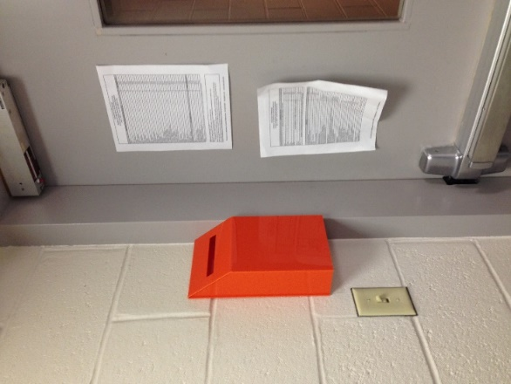

Yellow box by main entrance/exit:

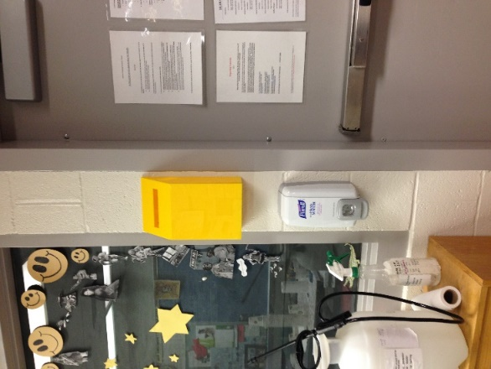

Yellow box by back red hallway entrance/exit:

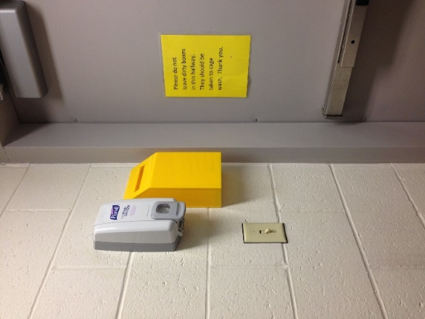

1. If you remove the DLAR white or purple bar coded card from the animal facility, ***you MUST*** immediately return to the facility and place into one of the collection boxes.
   1. When a DLAR white or purple bar coded cage card is not returned to a box, the cage will remain active in the system for three weeks and per diems will be charged for those three weeks even if the box is no longer in the facility. This can lead to over $25 in fees for a box of mice that no longer exists.

Any questions? See Alicia Frank, Danielle Reiser, or Deb Williams.