Standard Operating Procedures for Animal Shock Laboratory Protocol Mouse Hemmhorragic Shock + Bilateral Bone Femur Fracture + Soft Tissue Injury (STI)

Entire procedure is published in www.JOVE.com

All tubing, suture, two way connectors, and instruments are to be sterilized before use:
6-0 Suture, cotton tip applicators, gauze, two way connector, and instruments can be sterilized in autoclave.
Transducers, PE 50, and PE 10 tubing are to be Ethylene oxide treated through the hospital.
Ethylene Oxide sterilization is Located on the fifth floor of MUH. You must enter the surgical recovery section through the double doors by the transport elevators. Push intercom and ask to drop off materials.
Put all tubing and transducers in sterilization pouches and label each with: room number (NW 615 MUH), Dr. Billiar’s name, our phone number (7-5681), and GAS.
Fill out the small sheet that they use to identify our items and give to them before 1:30 p.m. for pick up the next day after 7:00 am.

Surgical area setup:
Blue pad with sterile pad over it
70% alcohol spray bottle
microbead sterilizer on
scissors, forceps, two hemostats, two dumonts, and microscissors
sterile suture
sterile cotton-tip applicators
sterile tubing, 30G needle, 3-way stopcocks
Keep all instruments on sterile pad

Transducer setup:
Hook up sterile transducer, two way connector, 23G needle, and sterile tubing according to digi med protocol – see diagram 1. www.JOVE.com
Follow calibration and zero procedure according to digi-med book

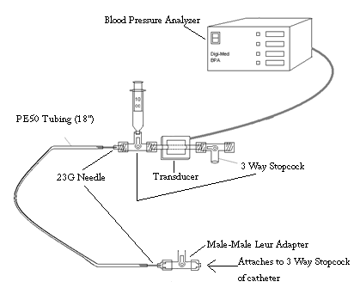
Surgical Procedure:

Bilateral Cannulations in order to continuously monitor BP throughout shock procedure.

Anesthetize mouse:
Inject IP Sodium Pentobarbitol (Heibers Pharmacy) 5mg/ml, 50mg/kg
ALL supplements given should be no more than 0.05cc at a time. Preferably, 0.05cc
Keep animals on heating pads and under lamp to ensure temperatures don’t drop excessively. Should remain around 35-36°

Get mouse catheter set up –see diagram 2 www.JOVE.com
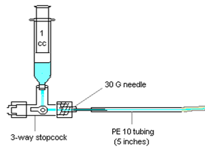
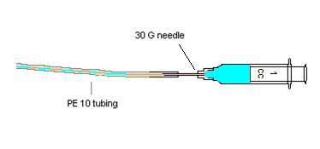
Bilateral cannulation PE 10 tubing w/ beveled edge
30G needle
3-way valve (for R-leg)
6-0 suture
For all mice: fill needle, three-way and PE 10 tubing w/ Lactated Ringers Solution. Fill 30G needle and PE 10 tubing only with Heparinized Saline
mixture [0.1cc heparin 1000U/ml : 9.9cc normal Saline]. This equals 10U/ml.
Leave ~ 0.1ml of your mixture in the syringe for the L leg for withdrawing blood.

The mouse receives a minute amount of the heparinized saline mixture which doesn’t interfere with inflammation.

*Keep in mind the mice don’t receive much of the this mixture, it is mainly to
keep the blood in the catheter and needle from clotting.

Concentration Heparin in HS mice: (X)(0.1ml) = (1000U)/(1ml)
X=10U Heparin in stock Mixture
(10U)(0.1ml) =1.0U/mouse

1000U *0.1ml *100U = 10U
1ml *10ml *10ml ml

10U *0.15ml = 1.5U
ml * ml ml

Tape mouse appendages to plastic board with cut tape - make sure not to stretch them out too far as it restricts breathing.
Shave surgical areas and wipe with betadine

Place mouse back under microscope on heating pad.

Place nose cone over mouse’s nose for a few seconds before making initial incision
Make small ~4-5mm incision parallel to groin muscle. This will allow for view of femoral vein, artery, and nerve.
Dissect out femoral vein and artery making sure not to damage surrounding muscle or touch nerves _(We isolated artery from vein but found it only enhances restriction of movement when recovering as more damage associated with surgery incurs)
Grab fat next to nerve with dumonts – DON’T TOUCH THE NERVE
Put 3 sutures around vein and artery
Suture 1 most proximal to groin muscle tie but leave loose hemostat off
Suture 2 most distal - tie off immediately and hemostat off
Suture 3 middle tie leave loose – to hold catheter in place after insertion
Make incision on top of femoral artery
Insert catheter into artery and tie off all 3 sutures – see diagram 3

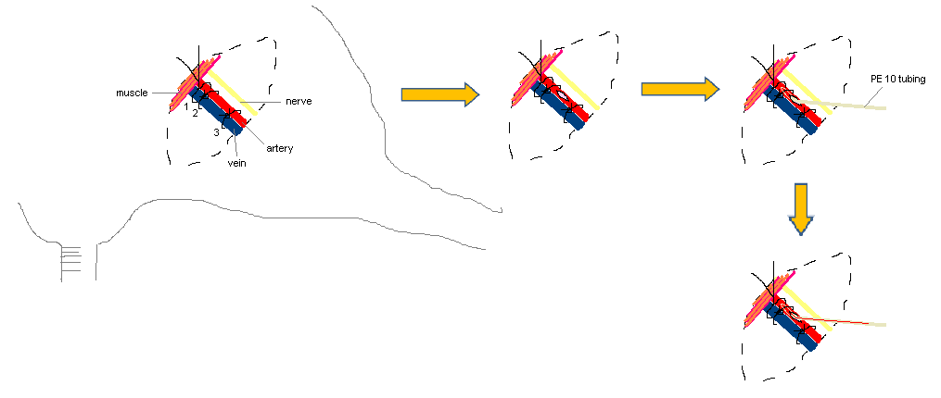

Pull blood out and push back into mouse several times to infuse heparinized fluid for blood clot prevention.

Repeat procedure for other leg
(I shock through L leg and put 3-way catheter into R leg for measuring BP)

Spray instruments with 70% alcohol and wipe with sterile gauze then put into microbead sterilizer for ~30 seconds to sterilize b/w animals
Spray instruments again w/ 70% EtOH to help cooling process and place onto sterile pad. Make sure there is no alcohol left on instruments that will drip back into the animals

Check animal temperature using rectal probe. DO NOT Start shocking unless body temp exceeds 34°

To shock (K) withdraw blood using L leg.
Usually takes about 15min (withdraw blood on syringe pump using chart)
Obtain BP around 26mmHg for shock
Maintain this pressure throughout 2.5 hours (or other times as denoted by
experiment request form) by withdrawing blood or flushing R leg cannula w/ LR

See experiment form for K time

Animal Body Temp should be recorded every 30-45min.

Begin recussitation (R): 3X SB in LR (see experiment form for direction) (we used to give back (SB) shed blood up to ~2005. Now, 2006 to present we just use LR no SB given)
R usually takes about 15-20min.
Hook up to syringe pump *ensure pump setting is o.k., which varies depending upon which pump is used. Pump should be set to deliver volume over a 15-20min period.
Ex) if 0.8ml of blood are withdrawn to reach 26mmHg give 2.4ml LR for Recus.
All recovering animals are sewn up with 3M skin glue or 4-0 silk suture. Keep method consistent throughout study.

BBFF - Hemostat
Place Hemostat ~ 2-3mm above knee with curve facing knee.
Place thumb on hemostat and pointer finger b/w hemostat and hip
Be sure to feel the femur before twisting so you know where you are breaking
Twist hemostat counterclockwise while twisting your other hand clockwise
Repeat for other leg

Soft Tissue Injury - STI
Using a large pair of hemostats (19 cm length), grab thigh muscle under the femur.
The convex curve of the hemostat should lie against the femur
Be careful not to grab the bone.
Squeeze muscle b/w hemostat and click to 1st click and hold for 30s.
After 30s release muscle and repeat on the other leg.
After 30s release hemostat. Repeat on the other leg

Pseudofracture – Pfx
See Pfx protocol

Sacrifice according to experiment form times– see tissue harvest protocol

Order of Events:
Femoral Cannulation
BFF
STI
PFx
Shock
Recuss

